📕 REDIS
📝 Redis Course Study Notes
1️⃣ Introduction
- This course is the first in the 'Get Started with Redis' path, designed for developers new to Redis.
- Instructor: David from the Redis Education Team.
- Objective: Learn what Redis is and how it helps build fast, scalable applications.
2️⃣ What is Redis?
- Redis is an in-memory key-value data store. ✅
- It is faster than disk-based databases because it stores data directly in memory.
- Redis is flexible and supports data persistence(data ko permanent save kar skta hai ) using append-only files(.aof) and snapshots(.rdb). ✅
- It is often described as a NoSQL database, requiring only knowledge of keys and data structures.
- Supports standard (strings, hashes, lists) and complex data structures (JSON, vectors). ✅
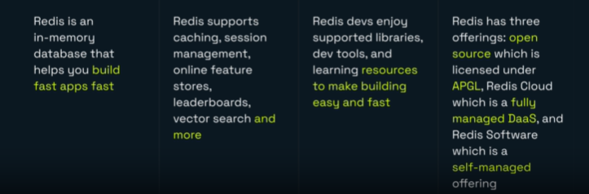
3️⃣ Core Features
- In-memory storage for high-speed data access.
- Key-value data model.
- Data persistence through snapshots and append-only files.
- NoSQL architecture – no need for complex joins.
- Supports a wide range of data structures including strings, hashes, lists, JSON, and vectors.
4️⃣ Use Cases
- Caching – Redis is widely used for implementing caching layers.
- Session Management – Ideal for managing user sessions in applications like e-commerce.
- Real-time Leaderboards – Used in gaming applications.
- Vector Search – Supports AI applications and vector databases.
5️⃣ Real-world Examples
- Voodoo (Wiz App): Uses Redis for caching, session management, and session state monitoring.
- HackerRank: Uses Redis for handling tens of thousands of submissions per minute and powering global leaderboards with probabilistic data structures.
- Dokugami: Uses Redis for generative AI tasks, including retrieval-augmented generation and vector search.

☁️ Redis Cloud Setup - Study Notes
1️⃣ Redis Cloud Setup Steps
- Visit redis.io and click 'Start for Free'.
- Sign up using Google or GitHub for easier integration with Redis Insight.
- In the Redis Cloud console, create a new database:
  - Use case: Cache
  - Subscription: Essentials (30 MB free tier)
  - Cloud vendor: AWS (default: US East)
  - Name: Default or custom
  - Enable Redis Stack for JSON and search features
- Click 'Create Database'.
- Copy the default user password from the Security section.
- Wait for the database status to change from 'Pending' to 'Active'.
- Use the 'Connect' button to access code snippets for Node.js, .NET, Python, Java.
- Optionally use Redis CLI with the provided command.
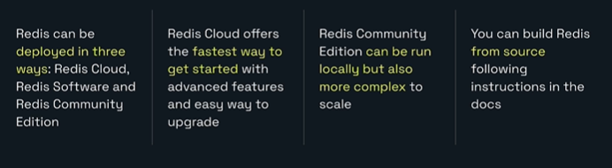

🔑 Redis Keys, Values, and Strings - Study Notes
1️⃣ Course Objective
- Understand what keys and values are in Redis.
- Learn how to read, write, and delete values using Redis commands.
- Understand the importance of naming keys effectively.
- Use Redis Insight CLI and GUI to interact with Redis.
2️⃣ Keys and Values
- A value is a piece of data to store: text, numbers, bytes, or complex structures.
- A key is the label used to retrieve the value.
- Together, they form a key-value pair.
- Similar to maps (Java), dictionaries (Python, C#), and objects (JavaScript).
- Redis is essentially a large map of keys and values.
3️⃣ Strings in Redis
- Simplest data structure in Redis.
- Binary-safe sequence of bytes.
- Can store: integers, binary data, JSON, text, images, videos, documents, sound.
4️⃣ Basic Commands (SET, GET, UNLINK)
- SET: Stores a value under a key. Example: SET color red → "OK"
- GET: Retrieves the value of a key. Example: GET color → "red"
- SET: To update the value of the key just again set it. Example: SET color orange → "OK"
- UNLINK: Removes a key. Returns number of keys removed.
5️⃣ Importance of Naming Keys
- Use meaningful and consistent naming conventions.
- Helps avoid confusion and key collisions.
- Use unique identifiers like UUIDs, customer IDs, product IDs.
6️⃣ Key Spaces and Hierarchy
- Key spaces group related keys using hierarchical prefixes.
- Similar to namespaces in programming languages.
- Use colons (:) to separate levels. Example: app:config:payment:port
- Redis Insight supports tree view for hierarchical keys.
- SET product:6379:name "Laptop"
- SET product:6379:price "75000"
- GET product:6379:name
- GET product:6379:price
- "Laptop"
- "75000"
7️⃣ Advanced String Operations
- Store and manipulate numbers (increment/decrement).
- Extract substrings.
- Perform bitwise operations.
- Store serialized JSON, binary data, and more.
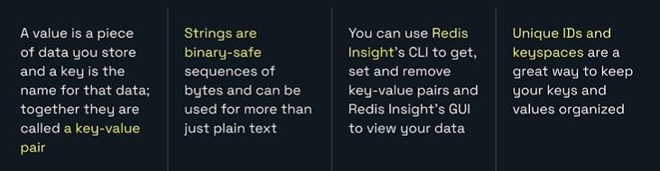

📋 Redis Lists - Study Notes
2️⃣ What is a Redis List
- A Redis list is an ordered collection of string elements.
- Elements are binary-safe strings (can store text, numbers, binary data).
- Order of insertion is preserved.
- Lists support operations on both ends (left/head and right/tail).
3️⃣ Basic Operations
- LPUSH key value [value ...] – Push elements to the left (head).
- RPUSH key value [value ...] – Push elements to the right (tail).
- LPOP key – Remove and return the first element (left).
- RPOP key – Remove and return the last element (right).
- LLEN key – Get the number of elements in the list.
- Example:
  - LPUSH recent:views bowtie bolo_tie ascot
  - LLEN recent:views → 3
  - RPOP recent:views → bowtie
4️⃣ Querying Lists
- LRANGE key start stop – Get a range of elements by index.
- LINDEX key index – Get a single element by index.
- Indices are 0-based from the left; negative indices count from the right.
- Example:
  - LRANGE recent:views 0 -1 → returns all elements
  - LINDEX recent:views 1 → returns second element
5️⃣ Practical Use Cases
- Queues: Push to one end, pop from the other (e.g., task queues).
- Stacks: Push and pop from the same end (e.g., navigation history).
- Ordered Data: Maintain order of user actions (e.g., recently viewed items).
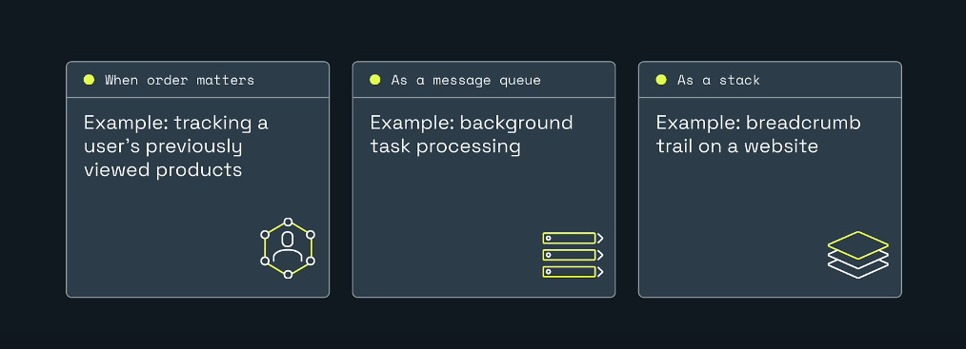
6️⃣ Advanced Operations
- Move elements between lists.
- Remove elements by value or range.
- Find matching elements.
- Use negative indices for flexible querying.
7️⃣ Examples
- Example 1: Creating a queue
  - LPUSH queue task1 task2 task3
  - RPOP queue → task1
- Example 2: Creating a stack
  - LPUSH stack page1 page2 page3
  - LPOP stack → page3
- Example 3: Viewing list contents
  - LRANGE stack 0 -1 → ['page3', 'page2', 'page1']
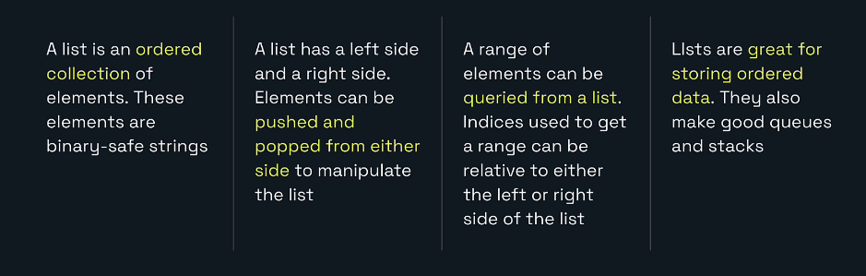
🔄 More List Examples
- LMOVE Example
  - LPUSH list1 task1 task2
  - LPUSH list2 taskA taskB
  - LMOVE list1 list2 LEFT RIGHT
  - → Moves 'task2' from list1 to the right end of list2.
- LREM Example
  - LPUSH products apple apple banana orange
  - LREM products 0 apple
  - → Removes all occurrences of 'apple' from the list.
- LTRIM Example
  - LPUSH recent:views item1 item2 item3 item4
  - LTRIM recent:views 0 1
  - → Keeps only the first two items and removes the rest.
- BLPOP Example
  - BLPOP queue 30
  - → Waits up to 30 seconds for an element in 'queue' and pops it.
- LINSERT Example
  - LPUSH tasks task1 task2 task3
  - LINSERT tasks AFTER task2 task2.5
  - → Inserts 'task2.5' after 'task2'.
- Finding Elements Example
  - LPUSH stack page1 page2 page3
  - LINDEX stack 1
  - → Returns 'page2'.

🧩 Redis Sets - Study Notes (Hinglish)
1️⃣ Overview
- Redis Set ek unordered collection hoti hai jisme duplicate members allowed nahi hote.
- Har member unique hota hai aur members binary-safe strings ho sakte hain (text, numbers, serialized data, etc.).
2️⃣ Kab Use Karein
- Jab uniqueness chahiye (unique visitors, unique emails).
- Jab deduplication automatic chahiye.
- Jab membership checks (kya user group ka member hai?) ya set math (union/intersection/difference) chahiye.
3️⃣ Basic Commands (Syntax aur Short Explanation)
- SADD key member [member ...]
  - Set me ek ya zyada members add karta hai.
  - Return: number of new members actually added (duplicates count nahi hote).
  - Example: SADD product:viewers Alice Bob Charlie
- SMEMBERS key
  - Set ke saare members return karta hai (unordered).
  - Example: SMEMBERS product:viewers
- SCARD key
  - Set ki cardinality (member count) return karta hai.
  - Example: SCARD product:viewers → 3
- SREM key member [member ...]
  - Specified members remove karta hai. Return = number removed.
  - Example: SREM product:viewers Bob
- SISMEMBER key member
  - Check karta hai ki member set me hai ya nahi. Returns 1 (present) ya 0 (absent).
  - Example: SISMEMBER product:viewers Alice → 1
4️⃣ Mathematical Set Operations
- SUNION key [key ...] → Union (sab unique members combined).
  - Example: SUNION set1 set2
- SINTER key [key ...] → Intersection (common members).
  - Example: SINTER set1 set2
- SDIFF key [key ...] → Difference (members in first set but not in others).
  - Example: SDIFF set1 set2
- SUNIONSTORE / SINTERSTORE / SDIFFSTORE destkey key [key ...]
  - Result ko naya set me store kar deta hai instead of returning to client.
  - Example: SUNIONSTORE resultSet setA setB
5️⃣ Advanced / Helpful Commands
- SRANDMEMBER key [count] → Random member(s) return karta hai (count optional).
  - Example: SRANDMEMBER product:views:bowtie42
- SPOP key [count] → Randomly pop karke return karta hai (and removes them).
  - Example: SPOP product:views:bowtie42
- SMOVE source dest member → Ek member ko ek set se dusre set me atomically move karta hai.
  - Example: SMOVE product:views:bowtie42 product:archived:bowtie42 alice
- SSCAN key [cursor] [MATCH pattern] [COUNT n] → Large sets ko iterate karne ke liye cursor-based scan.
  - SMEMBERS large sets pe expensive ho sakta hai, isliye SSCAN use karo.
8️⃣ Common Pitfalls
- Sets unordered hote hain — agar order chahiye to lists ya sorted sets consider karo.
- Duplicate detection cost nahi hai — Redis automatically ignore karta hai duplicates on SADD.
- SMEMBERS large sets pe memory aur latency issue create kar sakta hai.
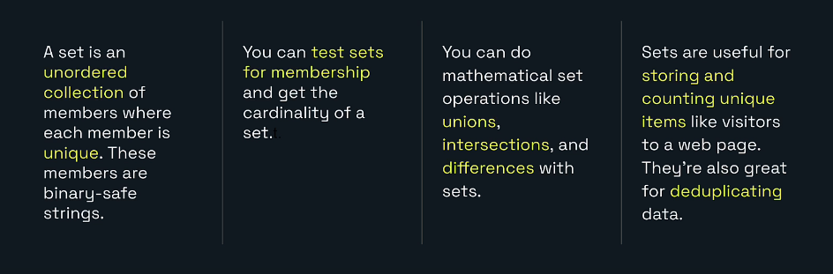

📦 Redis Hashes - Study Notes
1️⃣ Overview
- Redis Hashes = collection of field-value pairs stored under a single Redis key.
- Fields and values are binary-safe strings.
- Ideal for storing objects/records like product info, session data, cached DB rows.
2️⃣ Basic Commands (Lab Guide Examples)
- HSET (Set a single field)
  - HSET product:bowtie42 name "Awesome Bowtie"
  - 👉 Creates the hash if it does not exist.
- HSET (Set multiple fields)
  - HSET product:bowtie42 sku BOWTIE42 name "Awesome Bowtie" color red description "This awesome bowtie is the same color of red as the Redis logo." quantity 23
  - 👉 Return = 4 (since name already existed, 4 new fields added).
- HGET (Get a specific field)
  - HGET product:bowtie42 name
  - 👉 Output: "Awesome Bowtie"
- HGETALL (Get all fields)
  - HGETALL product:bowtie42
  - 👉 Returns all fields and their values (sku, name, color, description, quantity).
3️⃣ Advanced Commands (Most Used)
- HINCRBY (Increment/Decrement a field)
  - HSET product:bowtie42 quantity 23
  - HINCRBY product:bowtie42 quantity -3
  - 👉 quantity becomes 20.
- HDEL (Delete fields)
  - HDEL product:bowtie42 description color
  - 👉 Removes description and color fields.
- HRANDFIELD (Get random fields)
  - HRANDFIELD product:bowtie42 2 WITHVALUES
  - 👉 Returns 2 random fields with their values.
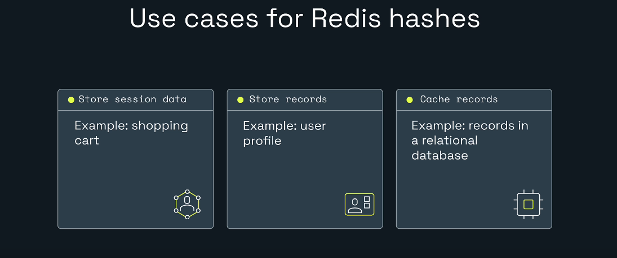

🥇 Redis Sorted Sets - Study Notes
1️⃣ Basic Commands (Lab Guide Examples)
- ZADD (Add members with scores)
  - ZADD products:ratings 5 BOWTIE42
  - ZADD products:ratings 4 BOWTIE43 3 BOWTIE44
  - 👉 Adds members with scores. Multiple arguments allowed.
- ZSCORE (Get score of a member)
  - ZSCORE products:ratings BOWTIE42
  - 👉 Returns score (e.g., 5).
- ZRANK (Get rank of a member)
  - ZRANK products:ratings BOWTIE42
  - 👉 Returns rank (zero-based, min to max).
- Update score (ZADD again)
  - ZADD products:ratings 2 BOWTIE42
  - 👉 Updates score for BOWTIE42.
- ZRANGE (Get members by rank)
  - ZRANGE products:ratings 0 -1 WITHSCORES
  - 👉 Returns all members with scores.
- ZRANGEBYSCORE (Get members by score)
  - ZRANGEBYSCORE products:ratings 4 5
  - 👉 Returns members with scores between 4 and 5 (inclusive).
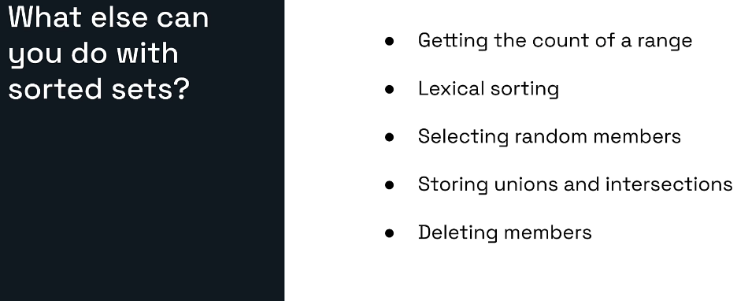
2️⃣ Advanced Commands
- ZUNION / ZINTER (Union & Intersection)
  - Perform unions and intersections on sorted sets.
  - Scores by default are summed.
  - Options: use MIN, MAX, or apply weights.
  - Example:
    - ZUNIONSTORE result 2 setA setB WEIGHTS 2 3 AGGREGATE MAX
    - 👉 Stores union in result with weighted scores and max aggregation.
3️⃣ Practical Use Cases
- Leaderboards: Track and rank scores in real time.
- Recommendation Engines: Intersect product scores for personalized suggestions.
- Analytics: Range queries, counts, random sampling.
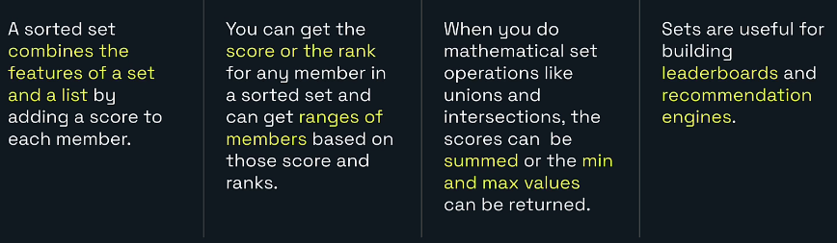

📄 Redis JSON - Study Notes
2️⃣ Basic Commands (Lab Guide Examples)
- JSON.SET (Add JSON document)
  - JSON.SET product:bowtie42 $ '{ "sku": "BOWTIE42", "name": "Awesome Bowtie", "colors": [ "red", "green", "blue" ], "description": "This awesome bowtie is awesome.", "quantity": 23, "onsale": false }'
  - 👉 Stores product record with multiple fields.
- JSON.GET (Retrieve document)
  - JSON.GET product:bowtie42
  - 👉 Returns entire JSON document.
- JSON.GET with JSONPath (Single field)
  - JSON.GET product:bowtie42 $.quantity
  - 👉 Returns [23] (array of numbers).
- JSON.GET with wildcard
  - JSON.GET product:bowtie42 $.*
  - 👉 Returns array of all root-level values.
🛠️ Manipulating JSON Documents
- Update boolean field
  - JSON.SET product:bowtie42 $.onsale true
  - 👉 Product marked as on sale.
- Add new field (price)
  - JSON.SET product:bowtie42 $.price 9.99
  - 👉 Adds price field.
- Update string field (rename product)
  - JSON.SET product:bowtie42 $.name '"Striped Bowtie"'
  - 👉 Renames product to "Striped Bowtie".
- Delete field
  - JSON.DEL product:bowtie42 $.colors
  - 👉 Removes colors field.
3️⃣ Practical Use Cases
- Session Data: Store user session attributes with typed values.
- Caching Records: Cache relational DB rows as JSON.
- Nested Data: Store complex objects with arrays and nested fields.
- Search & Indexing: Create indices to query JSON documents (advanced topic).
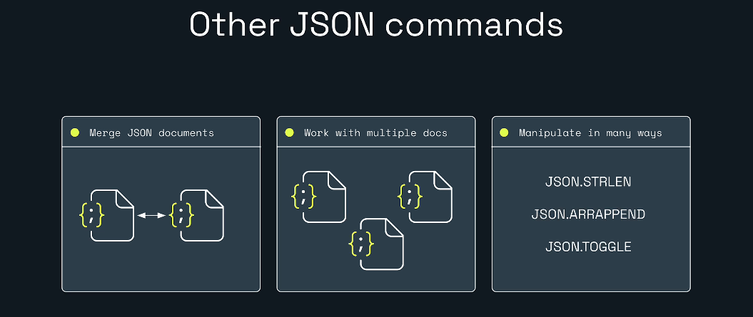
🚀 Redis JSON – Advanced Commands
1️⃣ Merge JSON Documents (JSON.MERGE)
- Purpose: Do JSON documents ko merge karna.
- Example:
  - JSON.MERGE product:bowtie42 $ '{ "discount": 15, "tags": ["fashion","sale"] }'
  - 👉 Adds new fields ( discount , tags ) into existing document.
2️⃣ Increment Numbers (JSON.NUMINCRBY)
- Purpose: Numeric field ko increment/decrement karna.
- Example:
  - JSON.NUMINCRBY product:bowtie42 $.quantity -5
  - 👉 Quantity reduce ho gayi by 5.
3️⃣ Append to Arrays (JSON.ARRAPPEND)
- Purpose: Array field mein naye values add karna.
- Example:
  - JSON.ARRAPPEND product:bowtie42 $.colors ‘"yellow"’ ‘"black" ‘
  - 👉 Colors array mein do naye colors add ho gaye.
4️⃣ Get Array Length (JSON.ARRLEN)
- Purpose: Array ke elements count karna.
- Example:
  - JSON.ARRLEN product:bowtie42 $.colors
  - 👉 Returns number of colors in array.
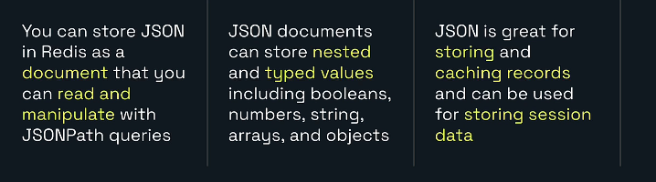

🔍 Redis Explore More Data Structures
1️⃣ Probabilistic Data Structures
- HyperLogLog
  - Counts unique items with ~0.81% error.
  - Memory efficient (~12 KB).
  - Example use: track unique visitors.
  - PFADD visitors user1 user2 user3
  - PFCOUNT visitors
- Bloom Filter
  - Tests membership: returns no or probably yes.
  - Space efficient, may give false positives.
  - Example use: check duplicate usernames.
  - BF.ADD usernames "gaurav"
  - BF.EXISTS usernames "gaurav"
2️⃣ Streams
- Record chronological events with unique IDs.
- Example use: event bus, clickstream.
- XADD mystream * user "gaurav" action "click"
- XRANGE mystream - +
3️⃣ Geospatial Indices
- Store members with latitude & longitude.
- Example use: find nearby stores.
- GEOADD stores 77.4126 28.6692 "GhaziabadStore"
- GEORADIUS stores 77.4126 28.6692 10 km
4️⃣ Vectors in Redis
- Store embeddings for semantic search.
- Example use: product description vectors.
- HSET product:bowtie42 embedding "[0.12,0.45,0.78]"
- Combine with vector search for recommendations.
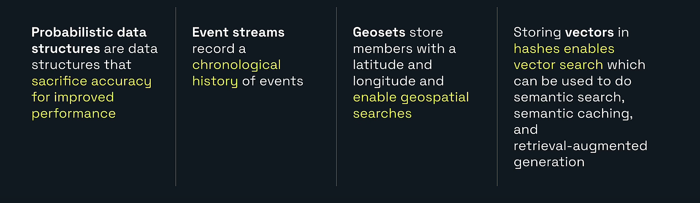

⏳ Redis Key Expiration - Study Notes
1️⃣ Key Expiration Basics
- Redis has two types of keys: persistent and volatile.
- Persistent keys remain until manually deleted.
- Volatile keys expire automatically after a defined time (TTL).
- By default, all keys in Redis are persistent.
2️⃣ Setting Expiration
- Example
  - SET bowtie:color red
  - EXPIRE bowtie:color 60
  - Return value 1 means success.
3️⃣ Checking Time-To-Live (TTL)
- Example
  - TTL bowtie:color
  - Positive number → remaining seconds
  - -1 → key exists but no expiration
  - -2 → key does not exist
4️⃣ Expiration Behavior
- Example
  - GET bowtie:color → (nil) after expiration
5️⃣ Persistent vs Volatile Keys
- Example
  - SET bowtie:pattern striped
  - TTL bowtie:pattern → -1 (persistent)
6️⃣ Explicit Expiration Time
- Example
  - EXPIREAT bowtie:pattern 4481067600
  - EXPIRETIME bowtie:pattern → same timestamp
7️⃣ Key Not Found Case
- Example
  - TTL bowtie:color → -2 (key does not exist)
8️⃣ Use Cases
- Caching → stale data auto removed
- Session Management → inactive sessions removed
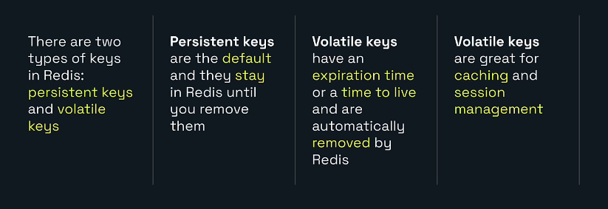

🛠️ Redis Use Cases - Study Notes
1️⃣ Caching
- Redis is widely used as a cache for fast data access.
- Delivers sub-millisecond response time.
- Improves user experience by reducing load time.
- Example: Product catalog loads instantly.
2️⃣ Search and Query
- Supports searching on hashes and JSON.
- Can filter by text, numbers, and location.
- Example: Search products by name, price range, and location.
3️⃣ Session Management
- Stores user session data like shopping carts.
- Provides fast read/write access.
- Ensures sessions persist across servers.
- Example: Cart remains saved after reopening website.
4️⃣ Vector Search
- Stores embeddings for semantic search.
- Used in AI applications like recommendations and chatbots.
- Example: Recommend similar products based on user behavior.
